**Architecture Document  
Smart Multi-Modal Soil & Crop Health Prediction System**

Review Stage: First Architecture Review

# 1. Application

## 1.1 Microservices

The system is implemented as a containerized microservices-style deployment to enable independent scaling, modular development, and fault isolation. The key services are: Frontend (React + Nginx), Backend API (FastAPI), Worker (ML + background jobs), Queue/Broker (Redis/RabbitMQ), Database (PostgreSQL), and Object Storage (S3/MinIO).

Key benefits in this project context:

* Independent scaling (API vs ML workers).
* Reduced API latency by offloading heavy compute to background jobs.
* Clear separation of responsibilities (ingestion, orchestration, inference, persistence).
* Deployment flexibility (compose/local → cloud/k8s later).

Deployment / Container Diagram (Mermaid):

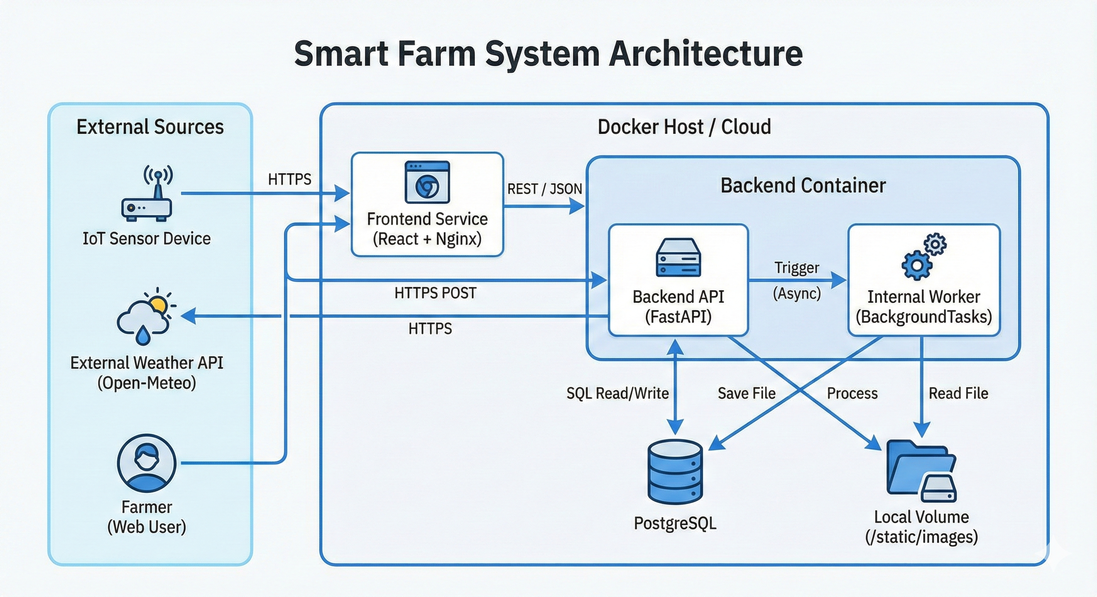

## 1.2 Event-Driven

Although the overall deployment is microservices-style, key parts of the system operate in an event-driven manner. Events are produced when sensors ingest data, images are uploaded, weather is refreshed, or recommendations are requested.

Event examples (logical):

* SensorReadingReceived(field_id, ts)
* ImageUploaded(field_id, image_id)
* WeatherUpdated(field_id, ts_range)
* RecommendationRequested(field_id)
* RecommendationGenerated(field_id, recommendation_id)

Event-driven flow (Mermaid):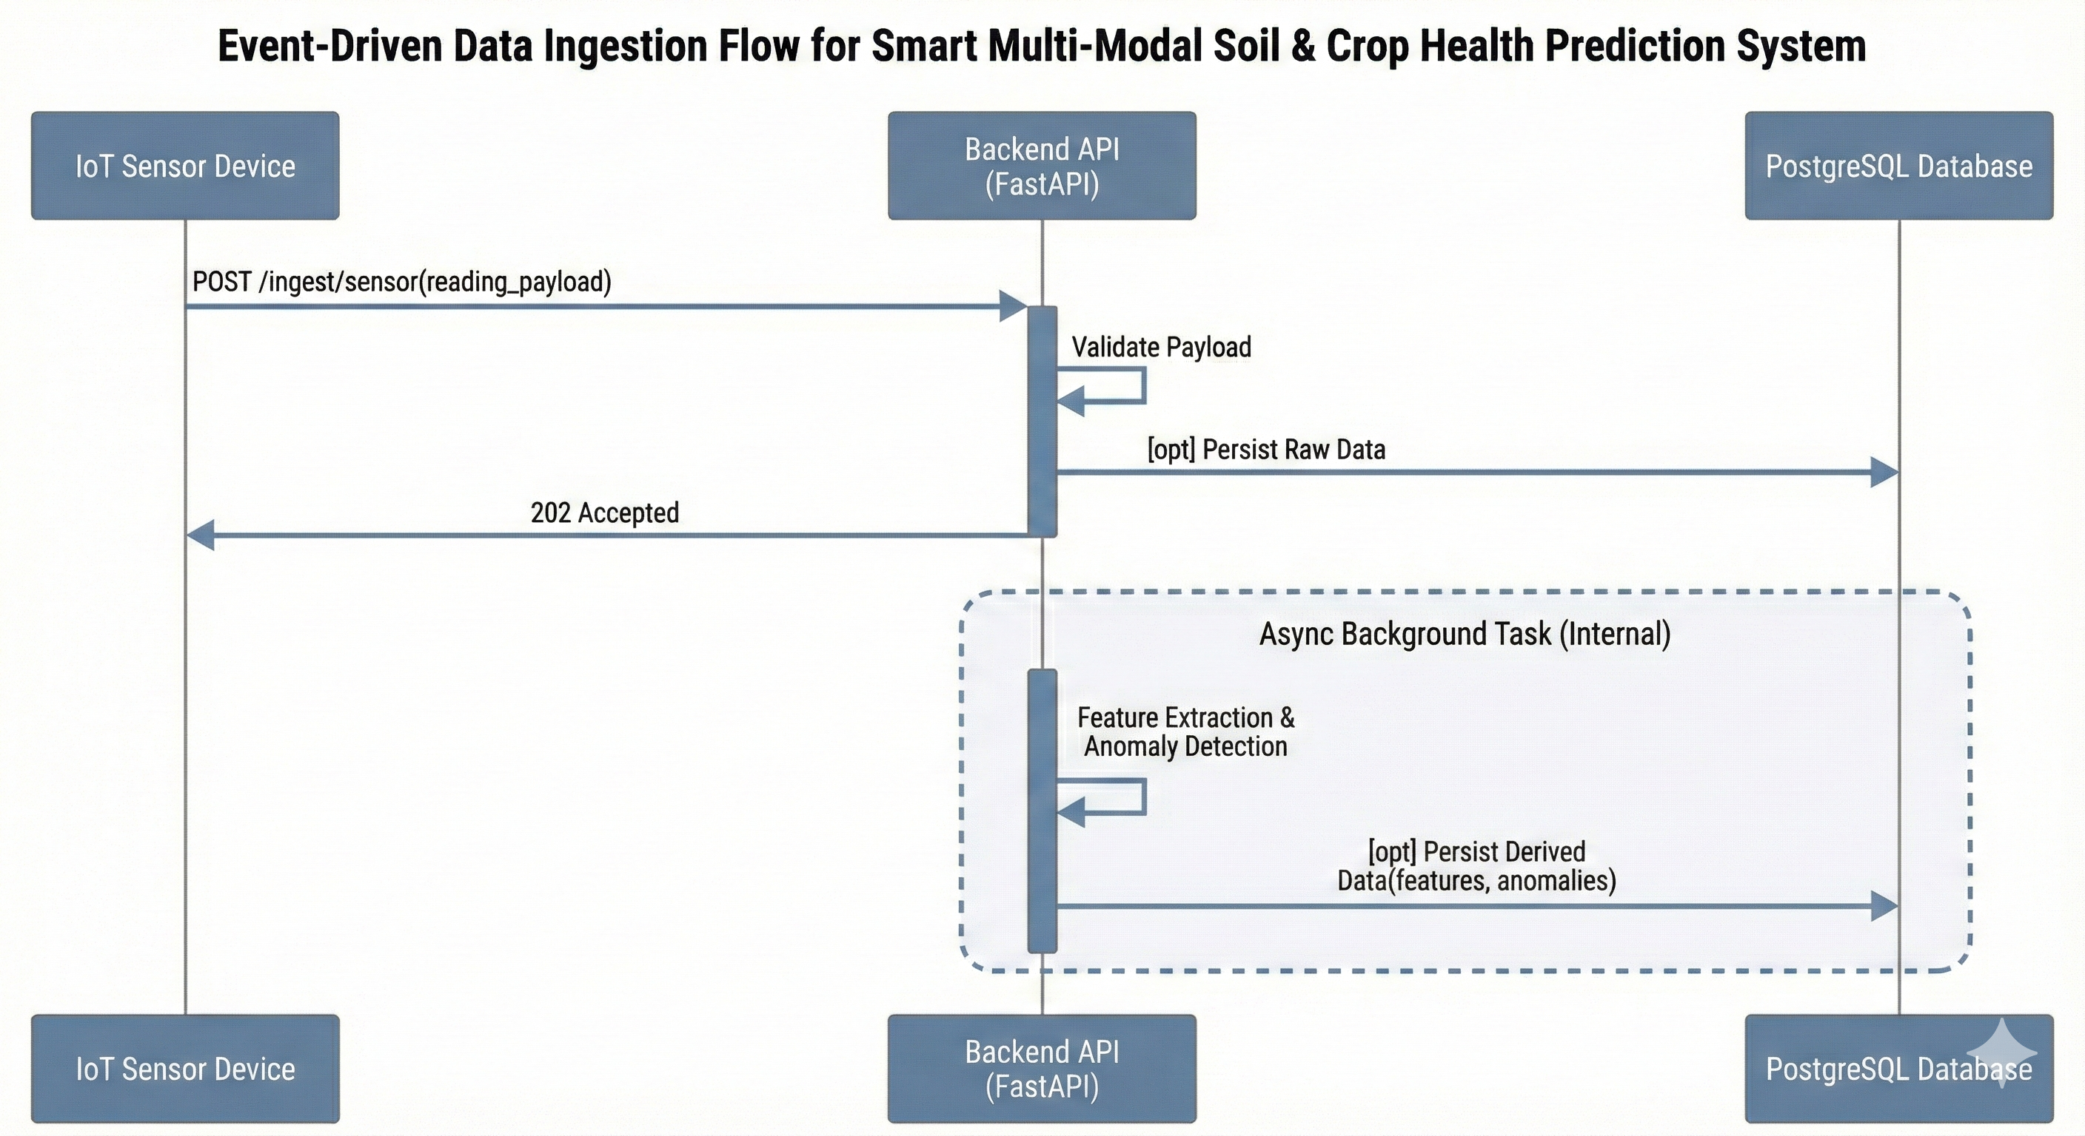

## 1.3 Serverless

A serverless architecture is feasible for selected workloads (burst-y compute, infrequent batch jobs), but it is not the primary deployment model in this first review. Potential serverless candidates include image preprocessing/inference (triggered on upload), scheduled weather refresh jobs, and periodic model evaluation.

Possible serverless mapping (conceptual):

* ImageUpload → Object Storage trigger → Serverless function runs preprocessing/inference.
* Scheduled cron → Serverless job pulls Open-Meteo and updates weather cache.
* Async recommendation job → serverless worker execution for burst capacity.

# 2. Database

## 2.1 ER Diagram

Entity-Relationship Diagram (Mermaid):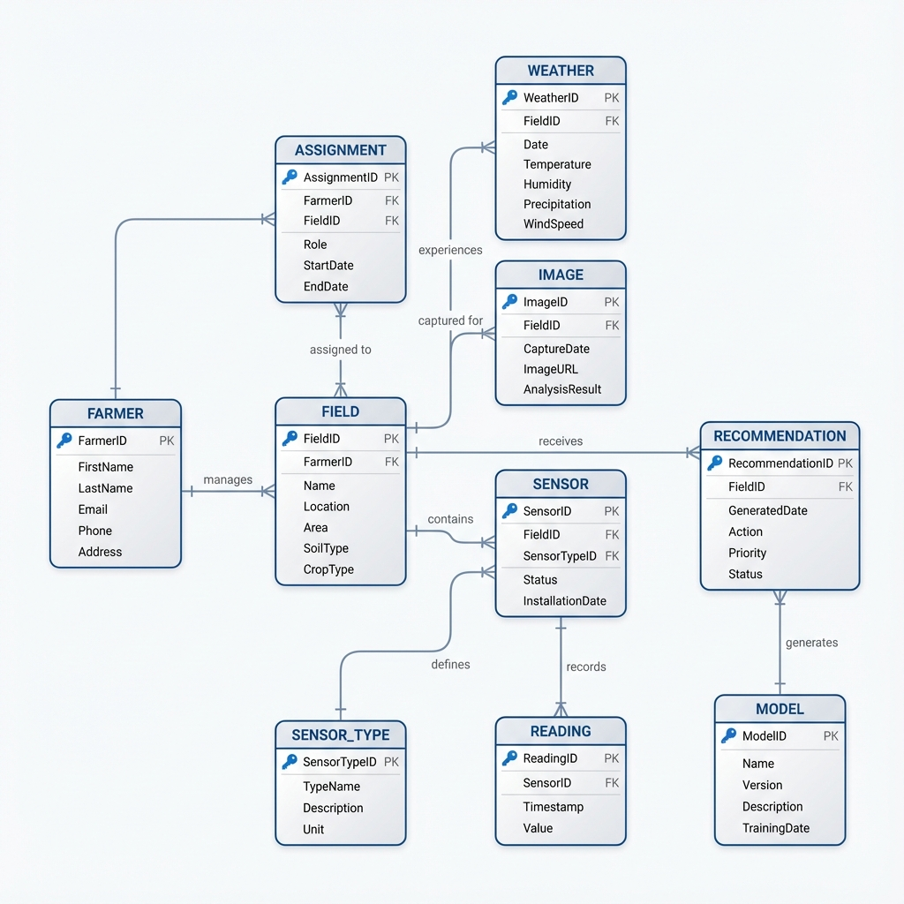

## 2.2 Schema Design

The relational schema is optimized for field-centric time-series queries (e.g., latest snapshot, last 7 days trends). Recommended indexes include (field_id, ts DESC) on sensor_readings and weather_readings. For scale, enable time-based partitioning or TimescaleDB hypertables.

|  |  |  |  |
| --- | --- | --- | --- |
| Table | Primary Key | Foreign Keys | Description |
| **Farmers** | id (UUID) | — | Farmer profile + credentials (password stored as hash). |
| **fields** | id (UUID) | farmer_id → farmers.id | Physical plot; location (lat/lon) + crop + growth stage. |
| **sensors** | id (UUID) | — | Device registry; includes type (Soil/Weather), metrics, and operational status. |
| **sensor_assignments** | id (UUID) | sensor_id → sensors.id field_id → fields.id | Tracks which sensor belongs to which field over time (active/inactive history). |
| **sensor_readings** | id (UUID) | field_id → fields.id sensor_id → sensors.id | Time-series soil telemetry:  ts, moisture, pH, N, P, K. |
| **weather_readings** | id (UUID) | field_id → fields.id | Historical and forecast weather: temperature, humidity, rainfall. |
| **images** | id (UUID) | field_id → fields.id | Image metadata; rgb_url stores the path/link and source denotes device (drone/phone). |
| **recommendations** | id (UUID) | field_id → fields.id | Advice output with action_json (Plan), why_json (Reasoning), and data_completeness score. |

Notes:

* Idempotency: enforce uniqueness on (field_id, ts, device_id) or (device_id, ts) to prevent duplicates during reconnect bursts.
* Retention: keep raw high-frequency readings for short term; store aggregated hourly/daily summaries for long term.
* Recommendations are immutable and versioned for auditability.

# 3. Data Exchange Contract

## 3.1 Frequency of data exchanges

Real-time / event-driven:

* User interactions (login, dashboards, field updates): target p95 < 300ms for synchronous API calls.
* Sensor ingestion: device-configurable, typically every 15–60 minutes; bursty after offline periods.

Scheduled / batch:

* Weather updates: poll Open-Meteo every 4 hours (or on field creation), with caching to reduce API calls.
* Model jobs: inference runs on-demand; retraining scheduled daily/weekly only if sufficient validated historical data exists.

## 3.2 Data Sets

Primary datasets managed by the system:

* Agronomic (S): {Moisture, pH, Nitrogen, Phosphorus, Potassium}
* Meteorological (W): {Temperature, Humidity, Rainfall, Forecast_72h}
* Visual (I): {RGB Image, Timestamp, Source Type, Quality Metadata}

## 3.3 Mode of Exchanges (API, File, Queue etc.,)

External → System:

* IoT Sensors → Backend API: HTTPS POST JSON to /ingest/sensor (device-authenticated).
* Weather Provider (Open-Meteo) → Backend API: HTTPS GET; normalized and stored as weather_readings.

Frontend ↔ Backend:

* Frontend SPA ↔ Backend API: REST over HTTPS (JSON).

Internal (async):

* Backend API → Queue: enqueue jobs (GenerateRecommendation, RunInference, ProcessImage).
* Worker → Queue: consumes jobs and writes outputs back to PostgreSQL and object storage.

Optional file-based mode (offline support):

* Bulk import/export as CSV for sensor data and reports (administrative operations).

# 4. Supporting Diagrams

## 4.1 Use Case Diagram

## 4.2 Class Diagram

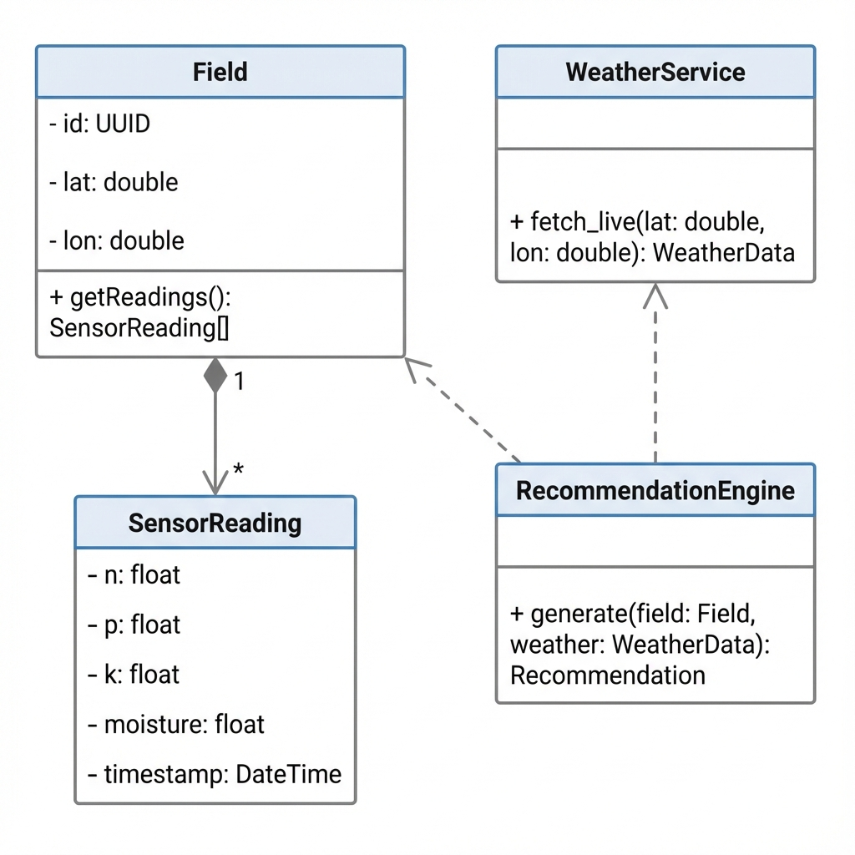

## 4.4 Component Diagram

## 4.5 Data Flow Diagram (DFD)

